Abstract Template for ETOT-I
Author One,¹ Author Two,^{2,*} and Author Three^{2,3}
¹Peer Review, Publications Department, Optica, 2010 Massachusetts Avenue NW, Washington, DC 20036, USA
²Publications Department, Optica, 2010 Massachusetts Avenue NW, Washington, DC 20036, USA
³Currently with the Department of Electronic Journals, Optica, 2010 Massachusetts Avenue NW, Washington, DC 20036, USA
*xyz@gmail.com
Abstract: Word manuscripts submitted to our journals may use these instructions and this universal template format. The template simplifies manuscript preparation and eases transfer between our journals. Authors will still need to adhere to article-length restrictions based on the final, published format. Authors may also submit articles prepared using this template. However, doing so is optional. Please keep the abstract up to one page.
- Figures
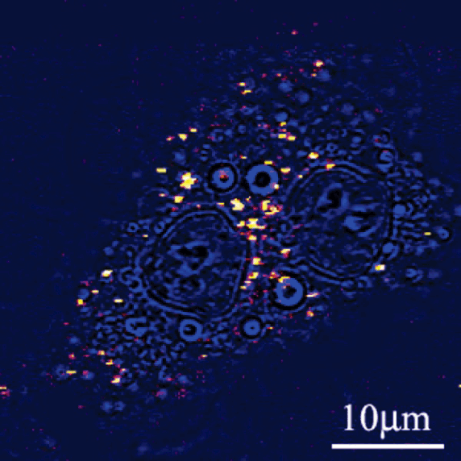
Fig. 1. Sample caption (Ref. [2], Fig. 2).

References
- A. Xyx and B. Xyx, “Title of the paper,” J. Opt. Soc. Am. B vol(issue), page no (Year).
- F. Author, “Title of preprint,” Optica Open 000000 (2023),
https://doi.org/10.1364/opticaopen.00000000.

